<!DOCTYPE html>

<html lang="en">

<head>

<meta charset="UTF-8">

<meta name="viewport" content="width=device-width, initial-scale=1.0">

<title>Contact Us</title>

<style>

body {

font-family: Arial, sans-serif;

margin: 20px;

max-width: 500px;

}

label {

font-weight: bold;

}

.error {

color: red;

font-size: 14px;

}

.preview {

margin-top: 20px;

padding: 10px;

border: 1px solid #ccc;

display: none;

}

</style>

</head>

<body>

<h2>Contact Us</h2>

<form id="contactForm" method="POST" action="/submit">

<label for="name">Name:</label>

<input type="text" id="name" name="name"><br>

<span class="error" id="nameError"></span><br>

<label for="email">Email:</label>

<input type="email" id="email" name="email"><br>

<span class="error" id="emailError"></span><br>

<label for="phone">Phone Number:</label>

<input type="text" id="phone" name="phone"><br>

<span class="error" id="phoneError"></span><br>

<label for="message">Message:</label>

<textarea id="message" name="message"></textarea><br>

<span class="error" id="messageError"></span><br>

<label>Preferred Contact Method:</label><br>

<input type="radio" name="contactMethod" value="Email"> Email

<input type="radio" name="contactMethod" value="Phone"> Phone

<input type="radio" name="contactMethod" value="Both"> Both

<br><span class="error" id="contactError"></span><br>

<label for="inquiry">Inquiry Type:</label>

<select id="inquiry" name="inquiry">

<option value="">Select an option</option>

<option value="General Inquiry">General Inquiry</option>

<option value="Support Request">Support Request</option>

<option value="Feedback">Feedback</option>

</select><br>

<span class="error" id="inquiryError"></span><br>

<button type="button" onclick="previewForm()">Preview</button>

<button type="submit" onclick="return validateForm()">Submit</button>

</form>

<div class="preview" id="previewBox">

<h3>Preview:</h3>

<p><strong>Name:</strong> <span id="previewName"></span></p>

<p><strong>Email:</strong> <span id="previewEmail"></span></p>

<p><strong>Phone:</strong> <span id="previewPhone"></span></p>

<p><strong>Message:</strong> <span id="previewMessage"></span></p>

<p><strong>Preferred Contact:</strong> <span id="previewContact"></span></p>

<p><strong>Inquiry Type:</strong> <span id="previewInquiry"></span></p>

</div>

<script>

function validateForm() {

let isValid = true;

document.querySelectorAll('.error').forEach(el => el.textContent = '');

let name = document.getElementById("name").value.trim();

let email = document.getElementById("email").value.trim();

let phone = document.getElementById("phone").value.trim();

let message = document.getElementById("message").value.trim();

let contactMethod = document.querySelector('input[name="contactMethod"]:checked');

let inquiry = document.getElementById("inquiry").value;

if (name === "") {

document.getElementById("nameError").textContent = "Name is required.";

isValid = false;

}

if (email === "" || !/\S+@\S+\.\S+/.test(email)) {

document.getElementById("emailError").textContent = "Valid email is required.";

isValid = false;

}

if (phone === "" || !/^\d{10}$/.test(phone)) {

document.getElementById("phoneError").textContent = "Enter a 10-digit phone number.";

isValid = false;

}

if (message === "") {

document.getElementById("messageError").textContent = "Message cannot be empty.";

isValid = false;

}

if (!contactMethod) {

document.getElementById("contactError").textContent = "Select a contact method.";

isValid = false;

}

if (inquiry === "") {

document.getElementById("inquiryError").textContent = "Select an inquiry type.";

isValid = false;

}

return isValid;

}

function previewForm() {

if (!validateForm()) return;

document.getElementById("previewName").textContent = document.getElementById("name").value;

document.getElementById("previewEmail").textContent = document.getElementById("email").value;

document.getElementById("previewPhone").textContent = document.getElementById("phone").value;

document.getElementById("previewMessage").textContent = document.getElementById("message").value;

document.getElementById("previewContact").textContent = document.querySelector('input[name="contactMethod"]:checked').value;

document.getElementById("previewInquiry").textContent = document.getElementById("inquiry").value;

document.getElementById("previewBox").style.display = "block";

}

</script>

</body>

</html>

### Explanation:

1. **Form Elements**:
   * Text fields for **Name, Email, Phone Number**.
   * Textarea for **Message**.
   * Radio buttons for **Preferred Contact Method**.
   * Dropdown for **Inquiry Type**.
2. **Validation**:
   * Name, email, phone, and message cannot be empty.
   * Email format is checked using regex.
   * Phone number must contain exactly 10 digits.
   * Preferred contact method and inquiry type must be selected.
3. **Preview Feature**:
   * Displays entered values on the same page before submission.
   * Ensures validation passes before previewing.
4. **Submission**:
   * Uses the POST method to submit data.
   * Calls validateForm() on submit to prevent submission if validation fails.

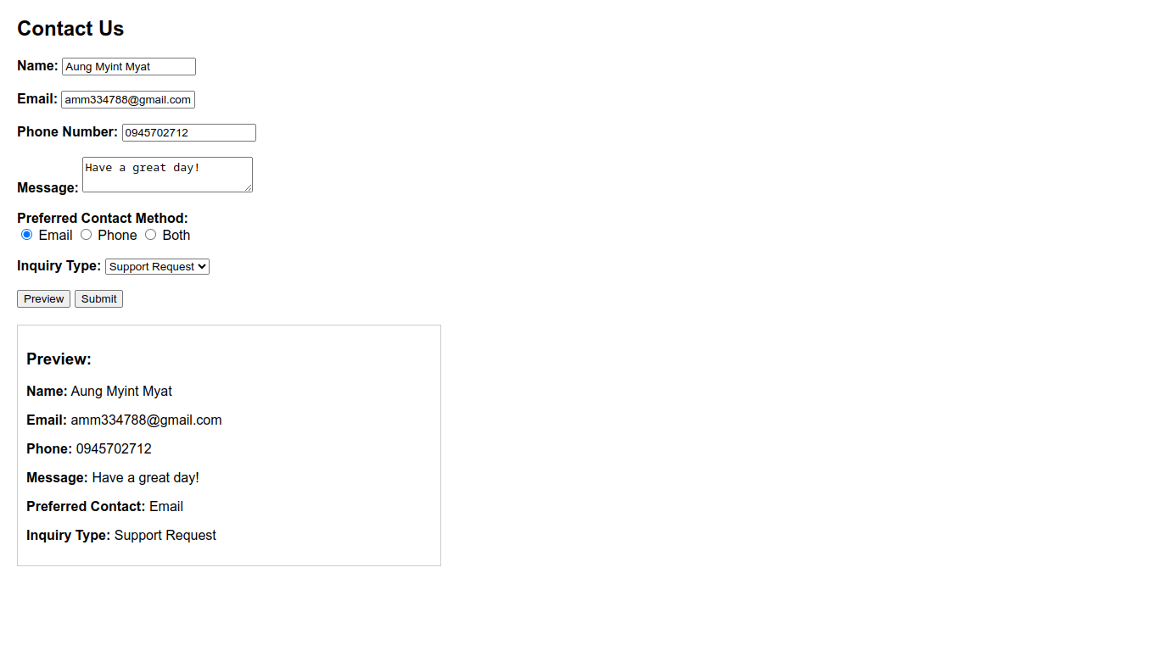Screenshots: